Whitchurch-Stouffville, Scott Heaslip & Olivia Petrie, Co-Chapter Chairs
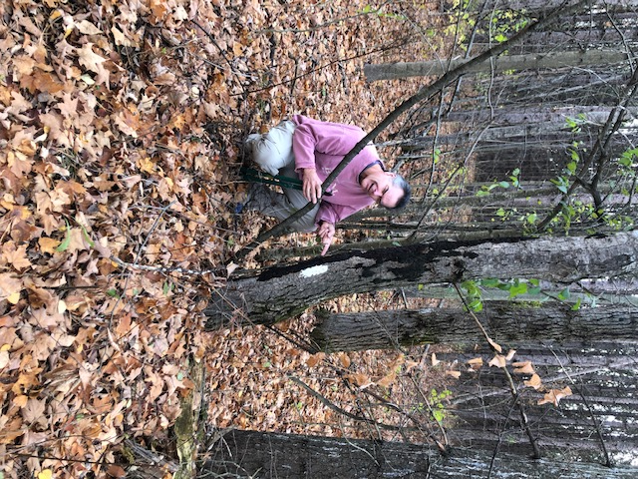
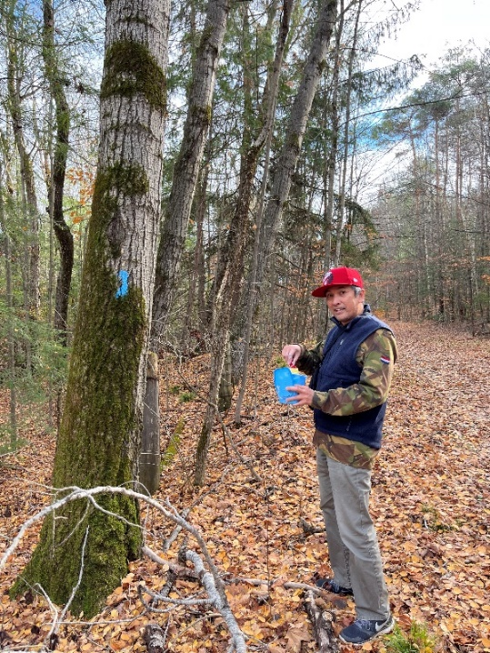
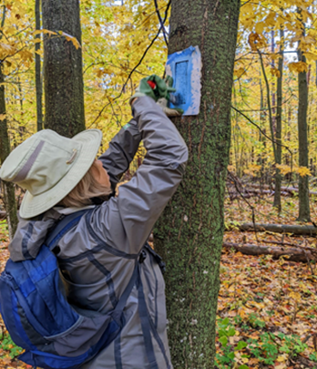
More than twenty volunteer trail captains in the Whitchurch-Stouffville Chapter look after eleven trail sections on the Oak Ridges Moraine. Nine of the trails are part of the York Region Forest and two are part of the Lake Simcoe Region Conservation Authority. The Chapter works closely with colleagues at the Region and Conservation Authority, who together ensure that the trails are well-maintained and easy to navigate. In 2022, through our spring and fall inspection undertakings, trail captains found most trails in relatively good condition and some issues requiring follow up, such as fences in need of repair and trail obstructions, were dealt with promptly and effectively. Trail captains also looked after touching up some trail blazes, loosening or replacing some of the signage, and cutting back smaller branches to maintain clearance on the trails. Notably, the amount of garbage collected during these inspections seemed to be less than in previous years, and we hope this trend continues. Importantly, hikers were quick to express appreciation to the trail captains while they were conducting their inspections, and we know this gratitude is shared broadly by all those who enjoy the use of these trails.
Mel Young
Daniel Braganza

Tracy McNaught
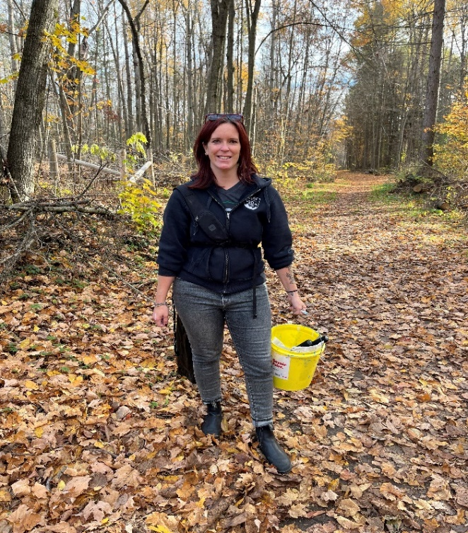
Also in 2022, we saw the departure of Caiti McLelland from her Co-Chair role, while she is thankfully continuing on as a Trail Captain. Back-up trail captain, Olivia Petrie, has taken on this role and is indebted to Caiti, as well as Co-Chair, Scott Heaslip and deputy co-chairs Tracy McNaught and Ryan Zylstra, as well as the ORTA Board, for their support through the transition. As 2023 unfolds, the W-S team will begin re-building the momentum from pre-pandemic times, and hope to engage volunteers and members in new ways. On the agenda so far are the Green Up Clean Up event organized by York Region to be held on Saturday, May 13, 2023, and an ORTA booth at Stouffville’s Strawberry Festival to be held on Saturday, July 1, 2023. More details on these events, including how to get involved, will be coming soon.
Caiti McLelland

